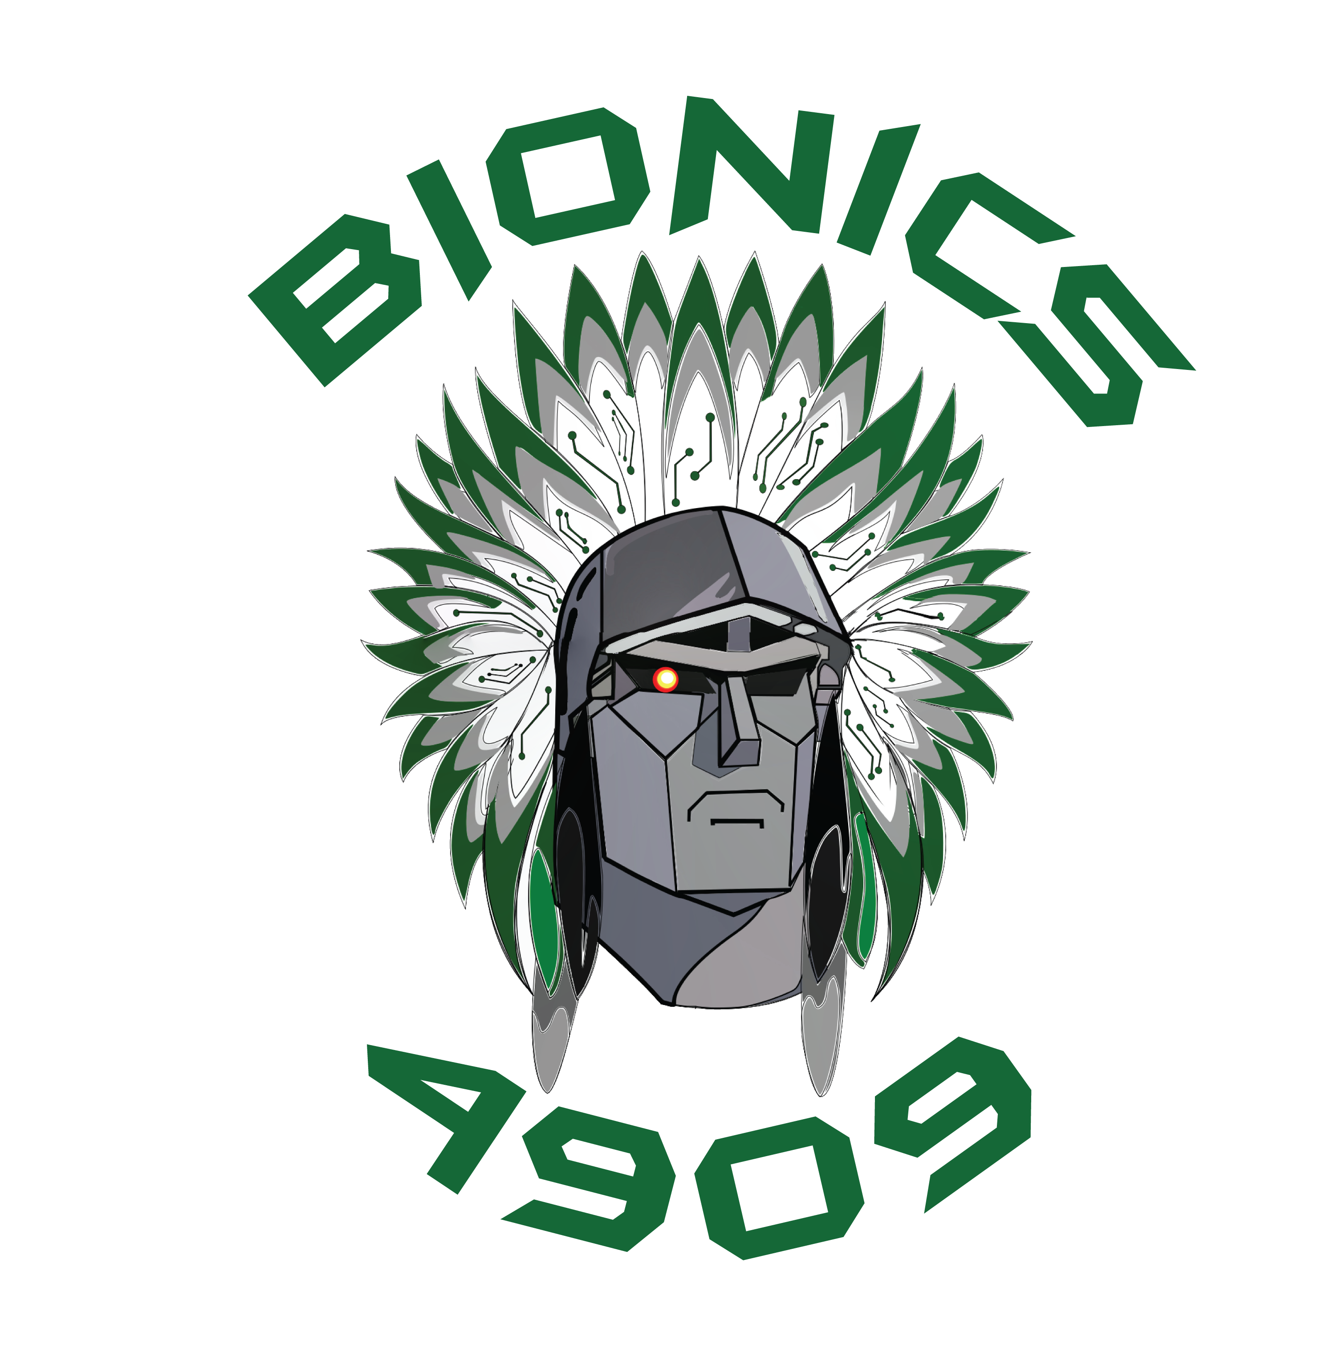 | FIRST Robotics Team 4909  Billerica Bionics  Billerica Memorial High School

Dear Potential Sponsor,

We are Billerica, Massachusetts’ FIRST® Robotics Competition (FRC) Team 4909. We are a small group of highly motivated Billerica Memorial High School students who, with the help of generous mentors, are seeking to educate ourselves through hands-on, direct experience in the disciplines of engineering: mechanical and electrical, and motion control software. Our team operates as a small business, giving us insight into fields such as marketing, sales, accounting, and media production, with an added emphasis on personal integrity and a smart work ethic. We are counting on these experiences to help us select a career path that will enrich our lives and the lives of those around us.

As a seventh-year team for the 2019-20 FRC season, we are all for learning about engineering and building robots. Not only do we build award-winning robots and learn important lessons about engineering and teamwork, but we also spread the word of STEM (Science, Technology, Engineering, and Mathematics) and the message of FIRST: to bring technological opportunity and knowledge to every student, as well as cooperating while we compete through the ideal of Coopertition™. We did very well this past year, competing at a high level in several events in Massachusetts, New Hampshire, and even at the World Championships in Detroit. While we have experienced consistent success, we still have a long way to go and believe our future is bright.

We have partnered with local professionals, making connections in the community that, without FIRST, we would not have known existed. We are hoping that the individual talents of the team will come together to pave the way for future Billerica Memorial High School FIRST teams.
As high-school students, FIRST® gives us the opportunity to:
- Embody the FIRST® ideals of Gracious Professionalism and Coopertition™
- The challenge of building a competitive robot in 6 weeks.
- Develop our skills in design, project management, programming, teamwork, and strategic thinking.
- Learn from experienced STEM professionals.
- Gain real world experiences not available in a classroom.
- Compete for more than $20 million in college scholarships.

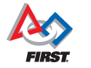 | FIRST® was founded in 1989 to inspire young people's interest and participation in science and technology. Based in Manchester, NH, the 501 (c) (3) not-for-profit public charity designs accessible, innovative programs that motivate young people to pursue education and career opportunities in science, technology, engineering, and math, while building self-confidence, knowledge, and life skills. For more information, please go to http://www.firstinspires.org

As a team that started in an old, overstuffed automotive shop with no tools, equipment, or supplies, we continue to face great expenses in continuing to outfit our team with the items needed to design and create efficiently and support a quickly growing team. We are therefore looking to our community for help that will allow our team to be competitive each year and attain the ultimate goal of participating in the World Championship in Detroit. We must also continually plan for the expansion and sustainability of our team, and for that, we need your help.

We invite you to invest in the great young minds of our future by making a contribution to our team.

- FIRST® Robotics Team 4909 “Billerica Bionics”

Highlights from FRC Team 4909’s History

- 2019 World Championship Qualifiers
- 2018 World Championship Qualifiers
- 2017 Battle of the Bay Champions
- One of only 15 teams (out of 175) in New England to qualify for New England Championship every year
- 2015 FIRST World Championship Qualifiers

Awards

- District Engineering Inspiration Award (2019, 2016)
- UL Industrial Safety Award (2019, 2018, 2014)
- Team Spirit Award sponsored by Chrysler (2019, 2015)
- Industrial Design Award sponsored by General Motors (2018)
- Quality Award sponsored by Motorola Solutions Foundation (2018, 2017)
- Gracious Professionalism Award sponsored by Johnson & Johnson (2015)
- Rookie All Star Award (2014)
- Highest Rookie Seed Award (2014)
- Rookie Inspiration Award (2014)

Outreach and Educational Activities

Our team conducts and participates in a wide variety of public outreach and educational activities. For our top-level sponsors, your company name and image will be continually present at these events and in blog posts as an integral part of our team’s public image.

Our team has also been involved with the robotics program at one of our middle schools, mentoring them as they create their own robots for competition. One middle school team joined the FIRST® Tech Challenge in 2015 and we have supported them since inception. We also take the time to work with the Billerica Recreation Department’s FIRST® Lego League team. These young engineers are the future of our program and we want to help them learn as much as possible so when they join us, they are skilled, contributing members.

The team participates in several outreach events during the school year where we are able to help spread the word about opportunities in the STEM fields. We demonstrated our robot for a few of our sponsors, hosted an Hour of Code© workshop for kids in our community to learn about programming, displayed our robots during the town of Billerica’s Yankee Doodle weekend, and threw out the first pitch at a Lowell Spinners game. We also make time to join our community in helping to keep it beautiful during its Green Up, Clean Up days.

During the Build and Competition seasons, we issue weekly email blasts to our supporters with a link to our blog to keep them up to date on our progress. The team also invites other local teams to come to our shop to use machinery and practice facilities to which they may not have access. We use the off-season to build our skills and perform demonstrations for our partners.

How Can You Help?

With an average annual budget of $30,000, participation in our robotics events is an expensive challenge. Your financial support is always greatly appreciated because we receive no funding from our school district. We are 100% funded through corporate and individual sponsorships. Please see our sponsorship levels below and we thank you in advance for your consideration.

The donation of tools, supplies, equipment, and services is another way in which your support can help our team have a successful season. Volunteer mentors are another great way to push our team towards meeting our goals. Students learning from people who work in STEM and business fields allow our students to experience firsthand what their future may hold.

Please contact team coach Matthew Flood (mflood@billericak12.com) if you are interested in making a non-financial donation or are interested in volunteering your time as a mentor.

FRC Team 4909 - Billerica Bionics
Levels of Sponsorship
 | Bronze  $1 - $499 | Silver  $500+ | Gold  $1,000+ | Diamond  $2,500+ | Platinum  $5,000+
Our sincerest thanks, an electronic copy of our blog posts and personal invitations to our local events. | 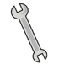
Your company’s logo within our local events and website and name listed on t-shirts
Your name and company logo on our banner.
Your name and company logo on our robot.
Your name included in our official team name, which appears in the FRC Competition Program and in FIRST financial reports.
Presentation by the team at your company.

FRC Team 4909 - Billerica Bionics
Sponsorship Pledge

Company/Organization: _____________________________________________________________

Contact Person: _______________________________________________________________________

Email: __________________________________________________________________________________

Address: _______________________________________________________________________________

City: _________________________ State: Zip: ____

Phone: __________________________ Fax: ___________________________

Sponsorship Amount:

Platinum Sponsor ($5,000+)

Diamond Sponsor ($2,500 -> $4,999)

Gold Sponsor ($1,000 -> $2,499)

Silver Sponsor ($500 -> $999)

Bronze Sponsor ($1 -> $499)

Please make checks payable to: Billerica Memorial High School
Our Federal EIN is: 04-6001089

Send check, along with this form, to:

Mr. Matthew Flood
Billerica Memorial High School FIRST® Robotics
35 River Street
Billerica, MA 01821
978-528-8700

Please provide your company/organization logo ASAP to Matthew Flood
(mflood@billericak12.com) for inclusion in FIRST® Robotics promotional materials.

Thank you for your time and consideration! We look forward to hearing from you!
Respectfully, FIRST® Robotics Team 4909 - Billerica Bionics
www.team4909.org

